Aerial Photograph

What is Aerial Photograph?
Aerial photography refers to taking photograph of earth surface from space. Platform of aerial photography includes aircraft, helicopter, balloon, parachute etc. Aerial photography was first practiced by the French photographer and balloonist Gaspard-Félix Tournachon, known as "Nadar", in 1858 over Paris, France. It was the first means of remote sensing with immense application potentiality even uses now-a-days in the age of satellites with sophisticated electronic devices.
The characteristics of aerial photography that make it widely popular are:
- Synoptic view point: Aerial photograph gives bird’s eye view enabling to see surface features of large area and their spatial relationships.
- Time freezing ability: Aerial photographs provide a permanent and objective records of the existing conditions of the earth’s surface at a point of time, thus can be used for historical records.
- Capability to stop action: They provide a stop action view of the dynamic conditions of earth’ surface features, thus useful in studying dynamic phenomenon such as flood, forest fire, agriculture etc.
- Spectral resolution and spatial resolution: Aerial photograph can be achieved sensitive to the electromagnetic (EM) wave outside the spectral sensitivity of human eye with very high spatial resolution.
- Three dimensional perspectives: Stereo-scopic view can be obtained from aerial photographs enabling for both vertical and horizontal measurements.
- Availability: Aerial photographs of different scales are available in websites approved by agencies involved in Aerial photography mission.
- Economy: They are much cheaper than that of field survey and more accurate than maps.

The aerial photographs that have been geometrically “corrected” using ground elevations data to correct displacements caused by differences in terrain relief and camera properties are known as Orthophotos.

Types of Aerial Photos
Aerial photos can be distinguished depending on the position of camera axis with respect to the vertical and motion of the aircraft. Aerial photographs are divided into two major groups, vertical and oblique photos.
i) Vertical photos: The optical axis of the camera or camera axis is directed vertically as straight down as possible (Fig.1). The nadir and central point of the photograph are coincident. But in real a truly vertical aerial photograph is rarely obtainable because of unavoidable angular rotation or tilts of aircraft. The allowable tolerance is usually +3º from the perpendicular (plumb) line to the camera axis. Vertical photographs are taken for most common use in remote sensing and mapping purposes.
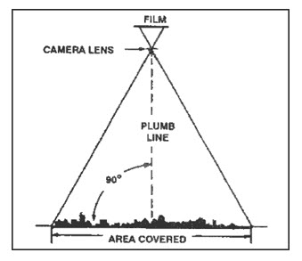
Fig. 1 Schematic diagram of taking a vertical photograph

A vertical photograph has the following characteristics:
(1) The camera axis is perpendicular to the surface of the earth.
(2) It covers relatively small area than oblique photographs.
(3) The shape of the ground covered on a single vertical photo closely approximates a square or rectangle.
(4) Being a view from above, it gives an unfamiliar view of the ground.
(5) Distance and directions may approach the accuracy of maps if taken over flat terrain.
(6) Relief is not readily apparent.

ii) Oblique photos: When the optical of the camera forms an angle of more than 5⁰ with the vertical, oblique photographs are obtained (Fig. 2). The nadir and central point of the photograph are not coincident.
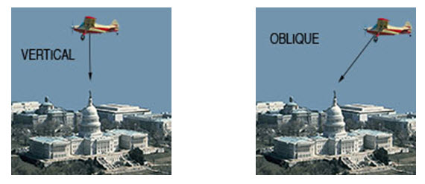
Fig. 2 Vertical and oblique photography
There are two types of oblique aerial photography – high angle and low angle. In high angle oblique aerial photography the resulting images shows the apparent horizon and in low angle oblique photograph does not. Oblique photographs can be useful for covering very large areas in a single image and for depicting terrain relief and scale.
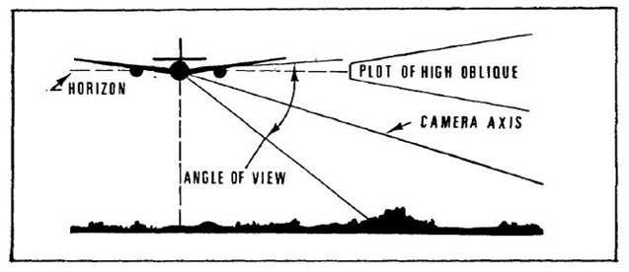
(a) High oblique
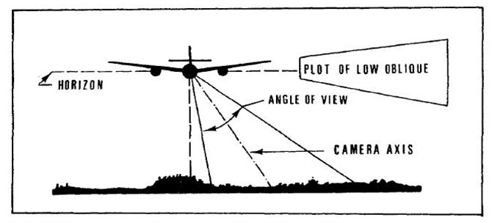
(b) Low oblique

A square outline on the ground appears as a trapezium in oblique aerial photo. These photographs can be distinguished as high oblique and low oblique. But these are not widely used for mapping as distortions in scale from foreground to the background preclude easy measurements of distance, area, and elevation.

An oblique photograph has the following characteristics:
- Low oblique photograph covers relatively small area than high oblique photographs.
- The ground area covered is trapezoid, but the photograph is square or rectangular. Hence scale is not applicable and direction (azimuth) also cannot be measured.
- The relief is discernible but distorted.

Basic Geometric Characteristics of Aerial Photographs
Aerial photographs are taken using a camera fitted at the bottom of a aircraft along a line is termed as flight line or flight strips and the line traced on ground directly beneath the camera is called nadir line. The point on photograph where the nadir line meets the ground is termed as principal point. Lines drawn to connect marks located along opposite sides of the photo (fiducial marks) intersect precisely at the principal point. The point on the photo that falls on a line half- way between the principal point and the Nadir point is known as isocenter. The ground distance between the photo centers (principal points) is called air base.
In aerial photography, the aircraft acquires a series of exposures along each strip of multiple flight lines. Successive photographs are generally taken with some degree of overlap, which is known as endlap (Fig. 3). Standard endlap is 60%, which may be 80-90% in special cases such as in mountainous terrain. It ensures that each point of the ground appears in at least two successive photographs essential for stereoscopic coverage. Stereoscopic coverage consists of adjacent pairs of overlapping vertical photographs called stereopairs. Beside endlap the photograph is taken with some overlap of photographs of a strip with the adjacent strip, known as sidelap (Fig 4). It varies from 20% to 30% to ensure that no area of the ground is missing out to be photograph.
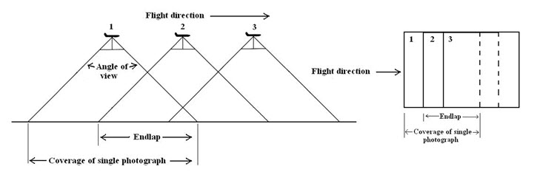
Fig. 3 Photographic coverage along flight line: endlap
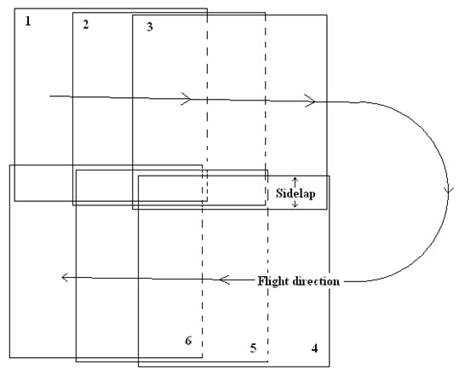

Fig. 4 Positions of aerial photos: sidelap

